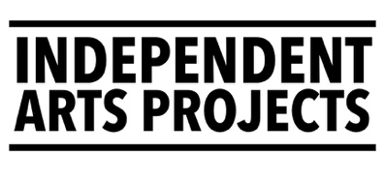
Independent Arts Projects (IAP) are looking for new volunteers to join our Board of Trustees.
It is important that our Board is made up of people with a range of experiences, skills and backgrounds to help us shape, support and realise our purpose.
Application deadline: 12pm Noon, on Tuesday 18 November 2025

Job Title | Trustees (up to 3 positions)
Hours | 4-6 meetings a year, and 1 annual company day / half day.  Trustees with particular expertise can be called on throughout the year, by mutual agreement, to give advice or offer insight.  Contributions to fundraising are also welcome. In December 2024, all trustees joined the Executive Director in a sponsored 24hr Board Games marathon. This was optional and each trustee contributed to the event in a way that was accessible for them.
Salary | None. This is a voluntary position; however reasonable expenses can be agreed in advance. Reasonable expenses might include travel, childcare costs, access costs. If you are unsure what else might count as a reasonable expense, please ask.
Term | 3 years, trustees can serve 2 terms maximum (of 3 years)
Supported by | Chair of the Board of Trustees (Natasha Lee-Walsh)
Line Manages | Executive Director
Location | Meetings are often online. Some meetings are held at  Independent Arts Projects’ office on Dalmeny St., Edinburgh.
Start date | From March 2026 or by negotiation.

Independent Arts Projects (IAP) works with some of Scotland’s most talented and innovative artists and performance makers to develop, produce and tour a programme of productions, arts projects, events and opportunities for people across Scotland and beyond. IAP projects often explore themes of identity and aim to make space for people to be themselves and see themselves.

IAP supports artists to be artists. To lead creative work, to develop meaningful relationships, artworks and experiences with communities of place, practice and identity.

IAP has produced 12 new theatrical works in the 6 years since it’s been trading. IAP productions have received four and five-star reviews from national media, sold out shows, and been nominated for awards.

In seven years, IAP has come to specialise in facilitating socially engaged arts projects with access and care at their core. Our work and practice have been included in case studies, and shared as examples of good practice, and been presented in 24 local authority areas across Scotland.

Vision:
- IAP contributes to a vibrant community of artists and arts workers who make creative encounters for and with people across Edinburgh, Scotland and beyond.
- Successful work is accessible, fun, meaningful, or transformative. It can be for people to experience passively as audience or actively as co-creators.
- Our artists, audiences and participants are diverse and representative of people of different ages, from different backgrounds, cultures and experiences.
Values
- Access & inclusion - everyone has a right to creativity.
- Becoming anti-ableist & becoming anti-racist - we work towards change.
- Experimentation - making space for creative risk taking.
- Sustainability (environmental, human, & financial).
- Wellbeing & care for people is at the heart of all we do.
- Trust & respect for everybody we work with.
Aims
- Produce an exciting & experiential programme of arts projects for audiences and participants
- Develop new pathways for leadership in Scotland’s arts sector
- Develop our audiences, partnerships, profile and impact
- Build our core team and overall capacity to match the company’s vision
- Develop our human, financial and climate sustainability

Independent Arts Projects Ltd is a company registered by guarantee and a registered charity. Company number SC581505. Charity number SC049294.
Visit our website to view projects: https://www.independentartsprojects.com
The current Board of Trustees

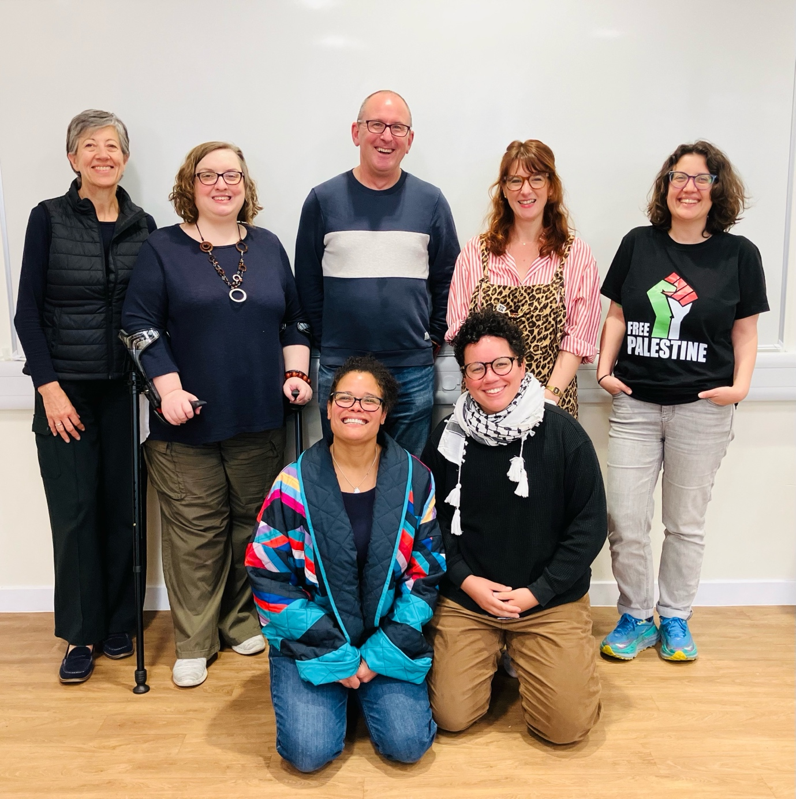
Figure 1: The Board of Trustees (top) Roz Bell, Michelle Rolfe, Leigh Mullin, Marion Geoffray, Sara Shaarawi, (front) Natasha Lee-Walsh & Ayo Schwartz
The company is supported by a board of volunteer trustees:
– Roz Bell (she/her), retiree, former Head of Live Performance, Eden Court
– Marion Geoffray (she/her), Artist & Creative Practitioner
– Natasha Lee-Walsh (she/her), MD, Edinburgh Open Workshop (Chair)
– Leigh Mullin (he/him), Consultant/Technical Architect in Technology
– Michelle Rolfe (she/her), Producer, Birds of Paradise & Co-Dir, Stage Sight
– Ayo Schwartz (they/she), Head of HR, National Theatre of Scotland
– Sara Shaarawi (she/her), Playwright

The representation across our current team and board is mainly female, with disabled, neurodivergent, LGBTQIA+ and ethnically diverse representation.

How We Work

We are a small arts organisation that aims to put access and care at the heart of all we do. We want the organisational culture to reflect our values and this central ethos.

The Staff Team
The Board of Trustees delegates the day-to-day running of the organisation to the Executive Director (full time) Mhari Robinson, (she/her), and she is supported by the General Manager (full-time), Chloe Lyth (she/they), and Producer (4 days a week) Nina Doherty (she/her). They are usually based at IAP’s first-floor office at Out of the Blue Drill Hall, 36 Dalmeny Street, Edinburgh, EH6 8RG (Leith).

IAP also currently employs/engages two Associate Artists: Max Alexander (he/him) (3 days a week) and Kirsty Biff Nicolson (they/them) (2 days a week).

There are also several lead artists who run regular, ongoing programmes with IAP and most of these happen in community, arts spaces, in schools, rehearsal rooms or theatres across Scotland.

IAP engages around 50 artists and arts workers each year.

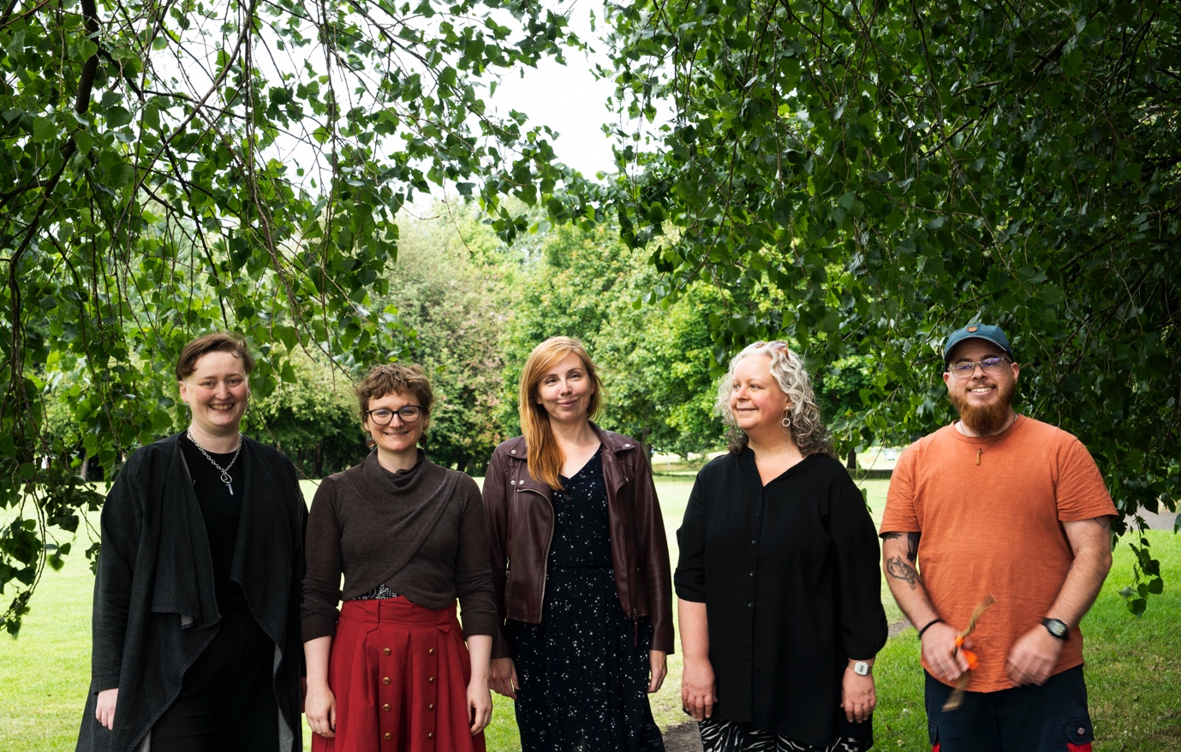
Figure 2: Staff Team - Kirsty Biff Nicolson, Chloe Lyth, Nina Doherty, Mhari Robinson and Max Alexander. Photo: Kat Gollock.

Job Description

The Board of Trustees has overall responsibility for the work of the organisation. The board of trustees meet regularly and work collectively taking decisions at board meetings. Trustees should ensure that the organisation is meeting its charitable purpose and acting appropriately with public money.

People who may not think they fit the typical criteria required for Board membership, but who are inspired to contribute to our work, are warmly encouraged to apply.

Trustees’ duties & responsibilities
- To lead, support and encourage the development of Independent Arts Projects
- To ensure that the company operates in a manner consistent with its purpose and principles
- To review and approve key staff appointments, business plans, policies and budgets
- To be an advocate for the work of Independent Arts Projects, building and promoting the company’s identity
- To act with care, diligence, skill
- To be fair and responsible employers
- To act with honesty and in good faith
- To ensure the company complies with the laws of Scotland, particularly the requirements of companies and charities law, employment laws, equalities laws, health & safety at work, safeguarding laws etc.
- To avoid and/or declare conflicts of interest
- To review and manage risk
- To ensure that the company acts within the terms of grants
- To ensure the production and distribution of accounts
- To treat company information as confidential
- To review and evaluate the performance of Independent Arts Projects
Person Specification

Skills, Attributes and Experience | Essential | Desirable
Commitment to ethical practice, integrity, objectivity, accountability, openness, honesty and leadership | ü
Commitment to diversity, equity, inclusion, belonging and justice | ü
Commitment to environmental sustainability | ü
Ability to think strategically and see the bigger picture. | ü
Commitment to handling challenging or sensitive situations with discretion | ü
Knowledge of financial management and accounting |  | ü
Knowledge of company, charity, employment, health & safety, safeguarding and/or equalities law in Scotland. |  | ü
Application timeline

Job pack goes live | Week of 29 September
Deadline for applications | 12pm noon, Tuesday 18 November
Interviews (Edinburgh/online) | November/December
All applicants notified of outcome | By 18 December

About the application process
- We will offer feedback to all applicants that apply.
- Applications will be considered by the Executive Director and Chair of the Board of Trustees.
- Shortlisted applicants will be invited for an informal conversation.
- Interviews can take place in person (in Edinburgh) or online via Zoom.
- Interviews will be with Mhari Robinson, Executive Director & Natasha Lee-Walsh, Chair of the Board of Trustees.
- We reserve the right not to appoint.

Applicants
We encourage applicants from different backgrounds with different experiences, skills and stories to join us and develop our working practice. We actively welcome candidates with protected characteristics and those who are currently under-represented in the arts including; people experiencing barriers due to socio-economic background, people who self-identify as LGBTQIA+, people who self-identify as D/deaf, people who self-identify as Disabled or Neurodivergent and those returning to work who have caring responsibilities. Ethnically diverse people who have experienced racism including people who are from African and Caribbean diaspora, Latinx, the East Asian Diaspora, the South East Asian Diaspora, from the South Asian Diaspora, West Asian Diaspora (including Middle East), Indigenous people, bi-racial / mixed heritage or who also self-identify as a Person of Colour or Black, or from the Global Majority we may use BIPOC+ to refer to people from these identities.
Before you apply
If you have any questions, you can email jobs@independentartsprojects.com with your questions and we will get back to you. Or let us know how would be best for us to communicate with you.
How to apply
- Please apply by sending a CV (maximum 2 pages A4) AND a brief covering letter/introduction by email to jobs@independentartsprojects.com
- Alternatively, applicants can send a link to a maximum 5-minute-long video of introduction
- Please complete our Equal Opportunities Monitoring form available here.
You do not have to complete the Equal Opportunities Monitoring form. However, it is a useful tool for helping us to monitor the effectiveness of our recruitment process. In accordance with the Data Protection Act 1998, the information you have provided will only be used for the purpose of equality monitoring.
Thank you so much.
Please visit us at www.independentartsprojects.com

