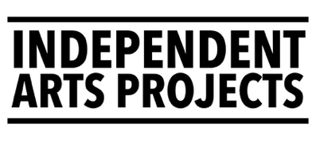
Associate Artist (0.4 FTE)
APPLICATION FORM
Application deadline: 12pm Thursday 12 March 2026
Please read the job pack before completing this form. If you have any questions about how to complete this application form, then please email jobs@independentartsprojects.com.
Alternatively, applicants can send a link to a maximum 10-minute-long video that outlines the information below.
Personal details | Your details
Name
Address
Email address
Telephone number
Link to your CV / details of your professional experience

Please complete the following:
- Summarise your creative practice. (up to 250 words)
- Tell us how your skills, experience, and knowledge match the points mentioned in the person specification in the job pack. (up to 250 words)
- Give a short description of the idea you would like to explore &/or develop. The idea does not have to be fully formed; we’re interested in your jumping off point. (up to 250 words)
- Tell us how you would consider people who face barriers to accessing mainstream arts (e.g. disabled, deaf or neurodivergent people, or, people from poorer backgrounds, or, people who have been racialised, etc) . (250 words)

Provide details of 2 referees
We will contact your referees after we make an offer subject to references.
 | Referee 1 | Referee 2
Name
Email address
Telephone number
Relationship to you

Please submit this completed application form to jobs@independentartsprojects.com along with your CV by 12pm Thursday 12 March 2026.

