Allies in Activism
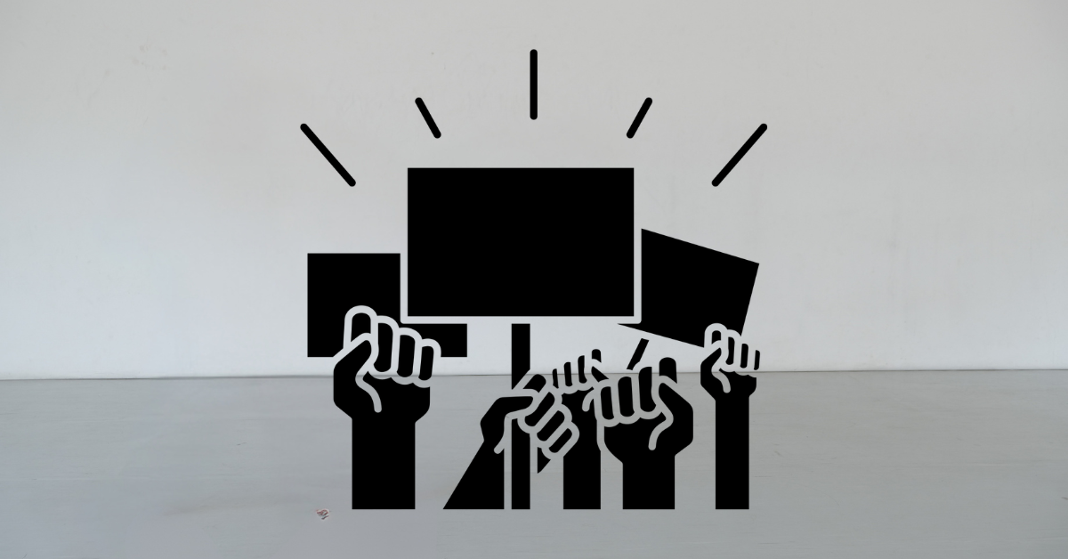
10.30am – 4pm, Wednesday 1 April, Eric Liddell Centre, 15 Morningside Road, Edinburgh, EH10 4DP
Allies in Activism* is a one-day event taking place in Edinburgh led by Jack Hunter, Ellen Renton and Independent Arts Projects.
The day will explore how we can build a safer, more supportive arts sector for D/deaf, disabled and neurodivergent artists, arts workers and audiences.
At a time when Access to Work grants are being slashed, we want to talk about what we can do in the performance sector in Scotland.
We very much hope that this event marks the beginning of something.
This event has been made possible with support from Birds of Paradise, Eden Court Theatre, Federation of Scottish Theatre, Imaginate, Magnetic North, National Theatre of Scotland, The Work Room & Unlimited.
* The title of the event came from an article in The Stage at the beginning of the year, where arts leaders were asked about the year ahead. Jenny Sealey (Graeae's Artistic Director) was quoted as saying: "For companies like Graeae, this past year has been fraught with Personal Independent Payments, Access to Work and Universal Credit. We need more allies in our activism. 2026 needs to be all-embracing to ensure the theatrical landscape is rich with diversity of people and narratives."
An audio version of this pack and additional venue information is available at:
https://www.independentartsprojects.com/allies-in-activism/
Schedule
10.30am | Arrival
11.00am | Welcome & Keynote presentations (45 mins)  - Welcome from hosts Jack Hunter & Ellen Renton  - Keynote presentation by Dr Sonia Allori  - Keynote presentation by Kirin Saeed  - Held in the mainspace, 4th floor.  - Live captioning, BSL.
11.45am | Break (15 minutes)
12pm | Panel Discussion: Access (45 minutes)  - A panel discussion on the topic of access  - Held by Ellen Renton & Jack Hunter  - With keynote presenters Sonia Allori & Kirin Saeed, and rest facilitator Liz Strange  - Held in the mainspace (Myreside Suite), 4th floor.  - Live captioning, BSL.
12.45pm | Break (15 minutes)
1pm | Lunch (1 hour)  - A vegetarian lunch with vegan & gluten free options, catered by Embo.  - In Robertson Suite on ground floor
2pm | Two simultaneous sessions:  Activism session (45 minutes)  - Facilitated by Briana Pegado  - In the mainspace, 4th floor  - Live captioning, BSL  Rest session (45 minutes)  - Faciliated by Liz Strange  - In the rest space, 2nd floor  - Auto generated captions by Otter.ai
2.45pm | Break (15 minutes)
3pm | Final reflections & pledges (45 minutes)  - Facilitated by Ellen Reton & Jack Hunter  - Space to reflect on the day  - Generate pledges / actions to take forward  - Final reflection by Nichelle Santagata  - Closing remarks from Jack & Ellen  - In the mainspace, 4th floor  - BSL, captions
4pm | Event programme ends (spaces stay open until 5pm)
Speakers and facilitators
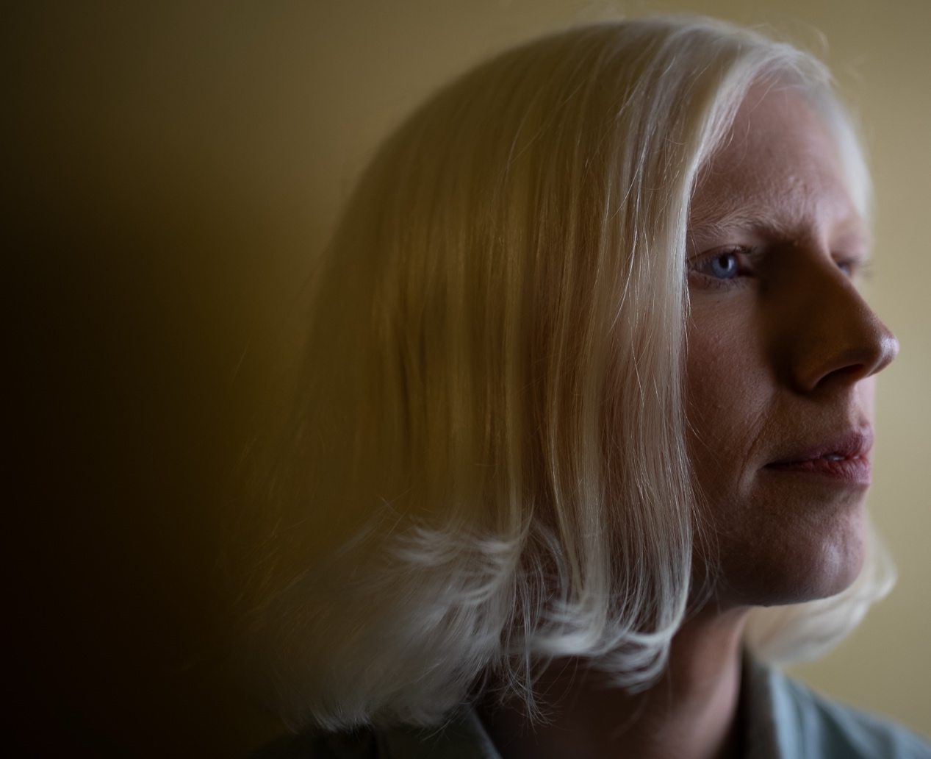
Ellen Renton (co-lead artist & co-host)
Poet, performer, and theatre maker from Edinburgh. Ellen Renton intertwines her own life with that of her family’s past creating a living, breathing record of history with contemporary relevance.
She published her pamphlet ‘An Eye For An Eye For An Eye’ with Stewed Rhubarb Press in 2021. Following this in 2023, she released the collaborative album ‘My Noise is Nothing’ with Lord of the Isles.
Ellen is the writer of one-woman show ‘Within Sight’, and the 2023 Stellar Quines production ‘Disciples’. In 2021 she was awarded an Emerging Scottish Literature Residency at Cove Park. In 2022 she was an Imaginate Jerwood Fellow, and an associate artist with the Edwin Morgan Trust and Disability Arts Online in 2022-23.
https://ellenrenton.co.uk
Photo: Douglas Tyrrell Bunge

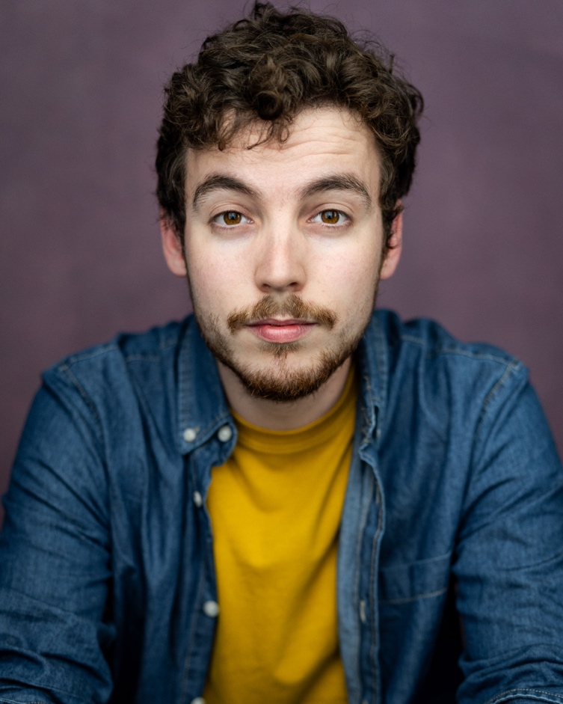
Jack Hunter (co-lead artist & co-host)
Jack Hunter is an award-winning disabled actor, writer and poet. Originally from Inverness, now based in Linlithgow. He graduated from Queen Margaret University’s BA Drama & Performance course in 2017.
As an actor, Jack has worked on stage and screen across the UK and Europe. Jack’s solo autobiographical play One of Two, presented by Independent Arts Projects, was staged at the Traverse Theatre in 2023 and has toured Internationally across Europe.
The production premiered, in association with Birds of Paradise Theatre Company, at the Edinburgh Fringe Festival in 2022 (Winner of the Summerhall’s Mary Dick Award). This production was nominated for Best Production (Scottish Theatre Awards at the Fringe). One of Two toured Scottish Schools as part of the Theatre In Schools Scotland Programme 2024.
Jack’s comedy drama The Wolves at the Door was part of A Play, A Pie and A Pint’s 20th anniversary season in Autumn 2024. Most recently, Jack has been awarded a Cove Park Residency in 2026. During which time he will research and write a new play.
https://jackhunter.uk
Photo: Yellow Belly Photography
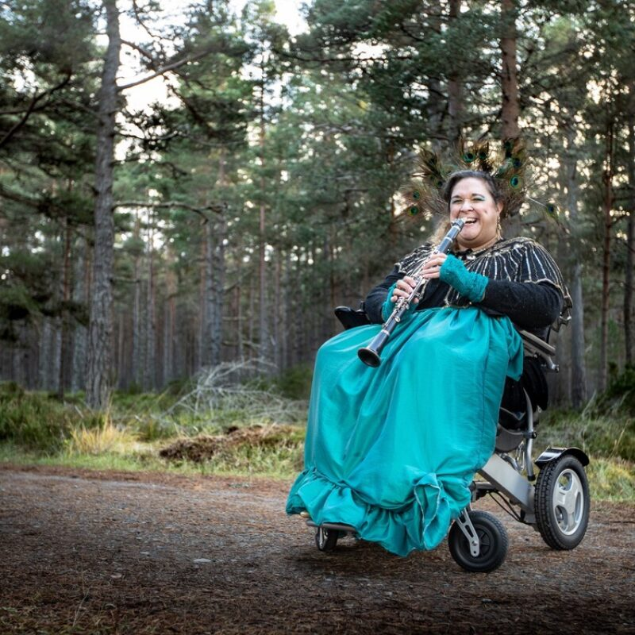
Dr Sonia Allori (keynote presenter & panellist)
Sonia Allori is a deaf and disabled composer, performer, researcher, music therapist, and multi-instrumentalist who sings from time to time. Her work explores access as a creative and generative force. Working across music, text, and live performance, she integrates live descriptive captioning, BSL, and multi-sensory approaches as core artistic material.
Her practice centres collaboration, shared authorship, and alternative ways of listening and experiencing performance, alongside a curiosity, a love of nature and place, and a sense of humour in the everyday. She is currently undertaking practice-based research at the Royal Conservatoire of Scotland, examining access-led approaches to composition and performance.
Sonia completed a PhD in composition at Edinburgh Napier University, where she explored interactions between words and music through the lens of gender and Italian contemporary classical music post-1900.
In 2023, she was commissioned by Drake Music Scotland to create Random Eddies in the Space-Time Continuum (for PRS Foundation’s Beyond Borders programme). In 2024, she created Robots and Dinosaurs for Nordic Days Festival, and was commissioned by Illuminate Women's Music to create The Goddess of Ballachulish for their Scottish Concert Series (2024/25).
Recent work includes Adventures in Captioning, an improvisatory performance system working with live and AI auto captions. Upcoming work includes There Are No Words and The Focus Group, both in development for 2026/27. Later in 2026, she will develop Creative Space, a pilot for an access-led online arts therapies practice.
https://soundcloud.com/ultraviolet101-1
Photo: Minttu Maari Mantynen

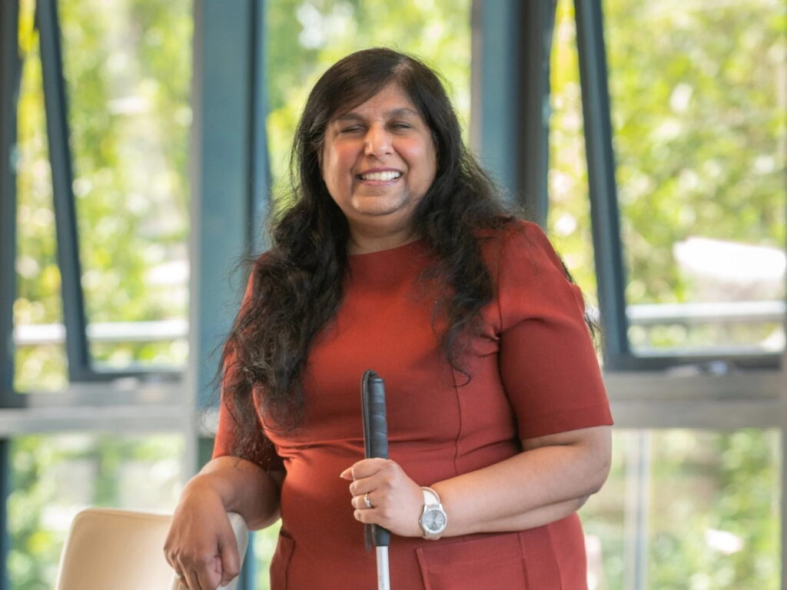Kirin Saeed (keynote presenter & panellist)
Kirin Saeed is the founder of Visually Impaired Creators Scotland (VICS) supported by Creative Scotland, a professionally trained actor, early career playwright and senior disability consultant.
Kirin has over 30 years’ experience of working in the disability sector as a disability consultant, and holds an MA in Human Resources from Northumbria University.
She is a professional actor trained through Graeae Theatre Company and London Metropolitan University through Missing Piece Program in 2003. She has toured with Extant, Britain’s leading professional performing arts company of visually impaired people, both in the UK and Europe.
Kirin is an avid user of audio description in theatres, cinemas and leisure facilities and hopes that one day access provision will be the norm for all blind and partially sighted people.
Kirin is also a Non-Executive Director and Trustee of the National Theatre of Scotland.
https://www.visuallyimpairedcreatorsscotland.co.uk/kirin-saeed

Liz Strange (Rest space & rest facilitator)
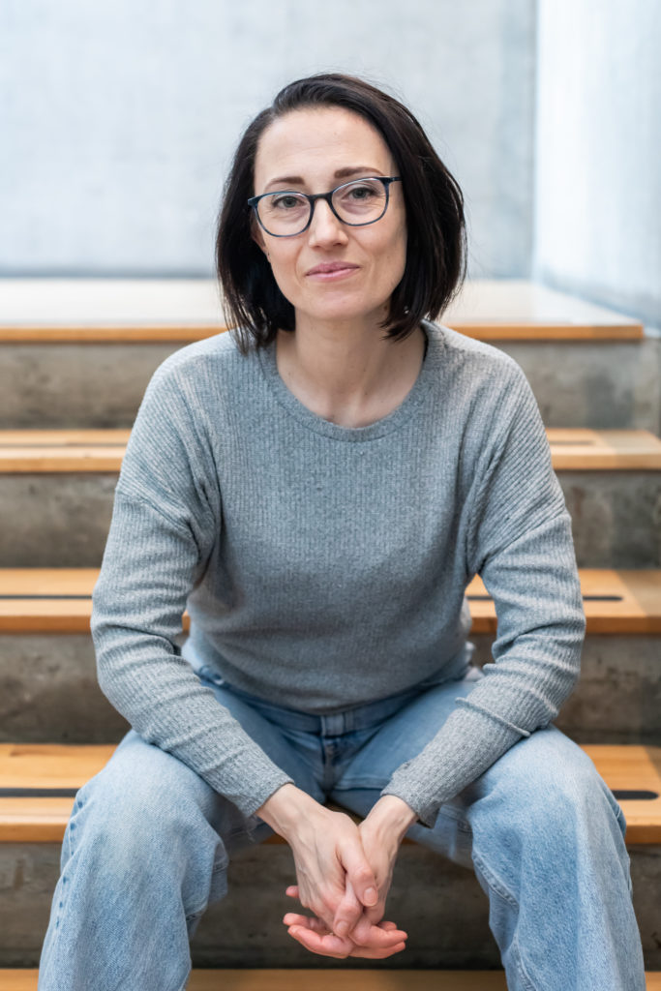
Liz Strange is an Edinburgh based actor, theatre facilitator, and physical theatre performer who specialises in visually driven theatre that is devised, interactive and subversive.
She has worked with companies such as Company Of Wolves, Mischief La-Bas, Al Seed Productions, Hearts & Minds, Tatraum Projekte Schmidt, Imaginate, Plutôt la Vie, Salty Dolls, Dance Base, Active Inquiry, Magnetic North and Surge.
https://lizstrange.co.uk
Briana Pegado (Activism facilitator)
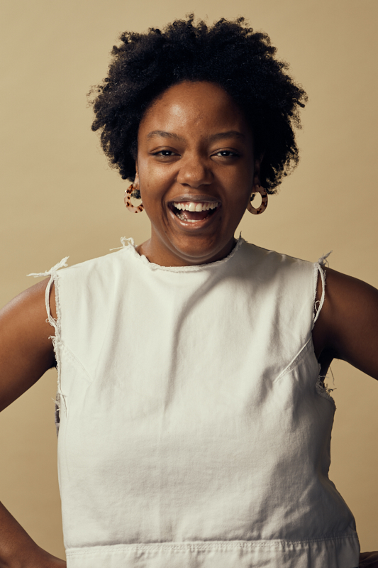
Briana Pegado FRSA is a neurodivergent author and artist. She explores the intersections of rest, grief and access in her work through poetry, moving image and contemporary art. When she is not making she is an anti-oppression and governance specialist working across the third sector to support organisations with ethical, values-led work. She is the Chair of the Scottish Government's Independent Culture Fair Work Task Force, which published a report last December containing 16 recommendations for Scottish Government to implement fair work in the cultural sector.
She currently works for the Royal Conservatoire of Scotland’s Creative Enterprise Development Office (CEDO) as a Career Advisor and is a Critical Friend for NEUK Collective's Spectra, a neurodivergent creative leadership programme pilot that launches next month.
Briana published her first book Make Good Trouble: A Guide to the Energetics of Disruption with Watkins Publishing in April 2024.
https://www.brianapegado.com
Activism session at 2pm in the Mainspace
Exploring Gentle Activism in an Arts Context - In this session, we will explore activism within an arts context and what shape our activism can take. Using Deepa Iyer's Social Change Ecosystem Map from the Building Change Movement, we will reflect on how activism is already embedded into our creative practice and cultural organisations while exploring how we can hone our skills as activists for deep systems change for disability justice.
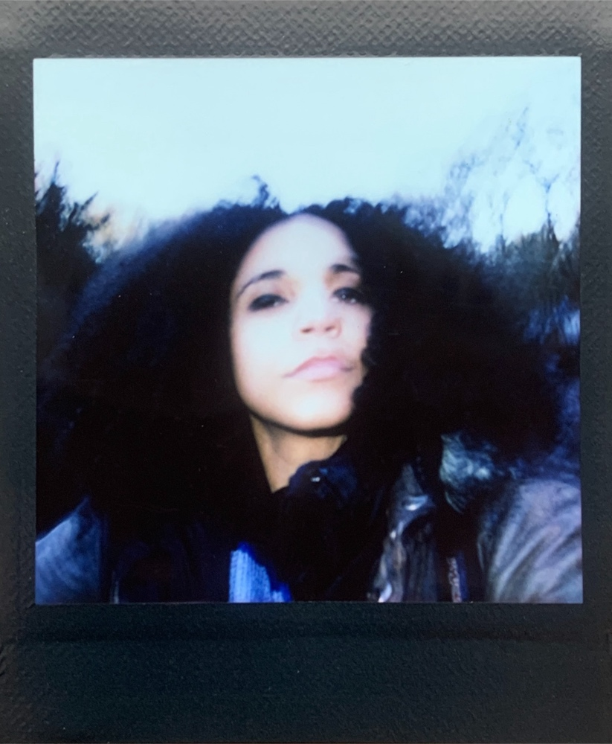
Nichelle Santagata (Final reflection)
Nichelle Santagata is a Cultural Knowledge Bearer; a Designer of Spaces and the Future; Prose-Poetry/Nonfiction/Fiction Writer; Hip Hop and Contemporary Dancer/Movement Artist; Spoken Word/Sound Artist; Radio Show Host-Disc Jockey/Music-Sound Art Selector; Filmmaker; Photographer; Archivist; Curator; Scrapbooker/Collage Artist; Textile Artist; Videographer; Illustrator; and Creative Director from so-called Arizona, United States/Turtle Island and currently based in Scotland.
Nichelle will obtain her PhD in Sociology focusing on Black Women’s Mental Health and Healing Through Arts-based Methods and Autoethnography, which incorporates many Practices such as Black and Indigenous Feminism and Disability Justice. Nichelle shares her Knowledges and Voice while on a journey of reimagining and rebuilding the world. She navigates learning and unlearning through a wide range of social, political, and economic justices and injustices amongst an abundance of cultures while living in and visiting various environments.
https://www.nichellesantagata.com

