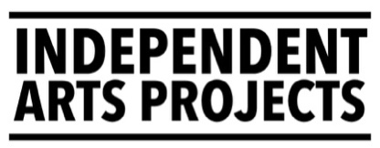
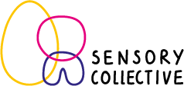
Sensory Artist
Application deadline: 12 noon Monday 21 September 2026
Job Title | Sensory Artist (4 jobs available)
Hours of Work | 0.6 FTE (21 hours/3 days per week)  Flexible days/hours between Nov 26 & Jan 28
Salary | £32,000 per annum (£19,200 pro rata)
Contract Length | 15 months, fixed term
Supported by | Producer (Sensory Collective), Associate Artist & Mentor
Works with  & alongside | - Sensory Artists  - IAP’s core team
Responsible for | Project Collaborators & Participants
Location | This is likely to be a mix of working from home / remote work, in temporary spaces with the team of artists and in community settings in Scotland.
Status | Employed fixed term contract (or freelance equivalent)
Start date | Week of 2 November 2026
Residency dates | Throughout the contract there will be short residencies where the Sensory Artists can work together, supported by the Associate Artist & Mentor. The first of these will be: Tuesday 3 to Thursday 5 November (3 days).
Holiday entitlement | 18 days per annum (30 days pro rata).
Probationary period | 2 months
Notice period | 2 months
Pension | The company makes a 5% contribution into the company’s pension plan on condition that the employee makes a minimum contribution of 5%
Disclosure Scotland | Successful applicants will be asked to share their PVG number so that IAP can submit a check to Disclosure
Flexible working & access - If you have particular access requirements and are unsure if this would be the right job for you, please ask. We’re open to flexible working arrangements (job share, reduced hours, remote working, annualised hours, etc). We aim to meet all staff access needs and provide a welcoming workplace.
If you are interested in applying but unsure if you fit the bill, please email jobs@independentartsprojects.com with any questions or to arrange a conversation.
Sensory Collective works to co-create sensory arts projects with people who face multiple barriers to accessing mainstream arts activities.

We will appoint 4 Sensory Artists and 1 Producer who will work collaboratively on between 1-3 new projects co-created with people who are neurodivergent and/or disabled between 1 November 2026 and 31 January 2028.

This might include autistic people, disabled people, learning disabled people or people living with dementia. This list is not exhaustive. We are hoping to appoint a team who have lived experience of being neurodivergent or disabled or a close connection to these communities or other communities who experience barriers to mainstream arts activities.

Projects will be co-created, so we don’t expect (or want) artists to have a fixed idea of what the outcomes of a project might be, but instead be led by shared fascinations and interests, to co-design their projects with people who face barriers to mainstream arts experiences. The artists will be supported by Biff Nicolson (Associate Artist & Mentor) and a Sensory Collective Producer (who will be appointed in autumn 2026).

In 2021, IAP brought together a team of seven to form the first Sensory Collective cohort. The project ran for almost two years and some of the projects created during this period are ongoing.

The original Sensory Collective cohort were Kirstin Georgia Abraham, Max Alexander, Dr Sonia Allori, Nina Doherty, K. Biff Nicolson, Niroshini Thambar and Joanna Young. The project included opportunities for sharing practice/learning, attending training, reading and connecting with other practitioners.
Co-created projects included:
- Function Schmunction, an autistic play space led by Max Alexander
- NeuroQueer Cabaret, which became Biff Nicolson’s We Dream Here project.
- Playing with the Elements, by Kirstin Abraham, working with neurodivergent families outdoors throughout the seasons.
- Sensory Movement workshops for Elders by Joanna Young, taking place at Dixon Community in Govanhill in Glasgow’s southside.
- 100s of 1-to-1 and small group experiences in homes, gardens, schools, care spaces.

Sensory Collective is made possible through funding from Culture Collective, a Creative Scotland/Scottish Government initiative that ensures at least 50% of the fund goes directly to artists fees & wages, and that contracts are a minimum of six months in duration. (It’s a great fund).
.
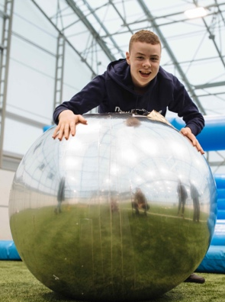 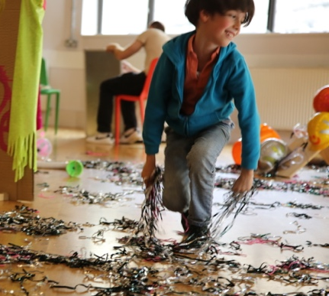 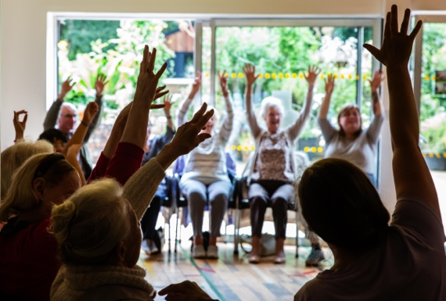
Photos (l-r) : Jassy Earl, Geraldine Heaney & Erika Stevenson
Job Description

The team of Sensory Artists will work collaboratively together to co-create multi-sensory arts projects with autistic, neurodivergent, and disabled people of all ages (including people labelled as having complex needs or as living with dementia).

Each artist will also work closely with Associate Artist & Mentor Biff Nicolson who will facilitate Sensory Collective residencies and peer practice sessions. They will also offer 1-to-1 mentoring & be a sounding board for the development of new ideas.

Each artist will have a budget of around £5,000 for project activity, £5,000 towards access costs for the people they work with and around £1,000 towards the training and the development of their artistic practice.

Responsibilities
Programme development and delivery
- Work closely with the Sensory Producer and Associate Artist & Mentor to plan, develop and deliver the Sensory Collective programme of co-created multi-sensory arts projects
- Regular engagement with individuals and small groups of people who are neurodivergent, disabled who face multiple barriers to mainstream arts
- Collaborate and co-create participative sensory arts activity with the Sensory Artists team & people who face barriers to the arts
- Work to ensure access is embedded into all areas of the project

Documentation, evaluation & reporting
- Contribute to documentation, monitoring and collation of evaluation. This may include photography, film, report writing, evaluation elements
- Contribute to the evaluation of the project, ensuring that learning is captured and applied as the project progresses
Other
- Observe safeguarding policies, processes and procedures
- Contribute to IAP’s purpose, vision, aims and objectives.
- Be led by IAP’s values (see page 6)
- Contribute to development of best practices around diversity, equality, and inclusion, belonging and justice
- Participate in residencies, meetings & training as required
- Any other duties appropriate to the post and organisation

Please note - applicants should have the right to work in the UK before they make an application. Unfortunately, we are not able to support applicants with work visas.

Person Specification

Skills, Attributes and Experience | Essential | Desirable
Experience delivering high quality, collaborative participatory arts work with groups of people
Interest in and knowledge of accessible and inclusive arts practices
Experience working with people who are neurodivergent and/or disabled
Good facilitation skills in inclusive participation settings (in person or online)
Ability to work alone and collaborate as part of a team
Ability to manage relationships and ensure effective & regular communications
Willingness to exchange learning & share practice in a peer group
Commitment to accessible & inclusive working practices
Commitment to promoting & embedding diversity, equity, inclusion, belonging and justice in working practices
Commitment to embedding environmental sustainability in working practices
Experience of documenting, evaluation & reporting
Knowledge of safeguarding

How to apply
- Please apply by sending a CV (maximum 2 pages A4, in no smaller font size 12) and completing the application form at the end of this pack attached by email to jobs@independentartsprojects.com
- Your application should cover the points mentioned in the person specification.
- There is a separate application form to download on the website
- Please include contact details for 2 referees. We will contact your referees after we make an offer subject to references.
- Alternatively, applicants can send a link to a maximum 10-minute-long video that outlines the above information.
- Please complete our Equal Opportunities Monitoring form* available here.

Application timeline
Job pack goes live | Week of 6 July 2026
Zoom Q&A for applicants | 12 noon, Wednesday 15 July
Deadline for applications | 12pm noon, Monday 21 September
Interviews | 9am – 5pm, Wednesday 30 September
All applicants notified of outcome | By Thursday 15 October

Application process
- Applications will be assessed and scored by the Executive Director, against the person specification. The highest scoring applicants will be invited for interview.
- We will guarantee an interview to any applicant who is either disabled and / or is from the global majority* who also meets the minimum person specification criteria.
- Applicants invited to interview will be sent interview questions at least 48 hours in advance.
- Interviews can take place in person (in Edinburgh) or online via Zoom.
- Interviews will be with Executive Director and 1 other person to be confirmed (this information will be sent with interview questions/invitation to interview).
- An offer, subject to positive references will be made following interviews.
- We reserve the right not to appoint
Before you apply
To arrange an informal discussion, sign up to attend the Zoom Q&A (15 July), or if you have any questions, please email jobs@independentartsprojects.com with any access requirements/preferred response (phone/sms/email), and we will get back to you.
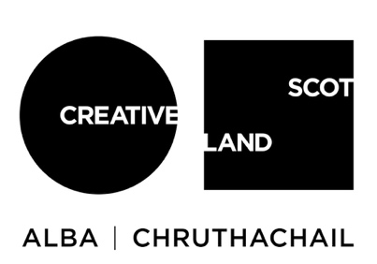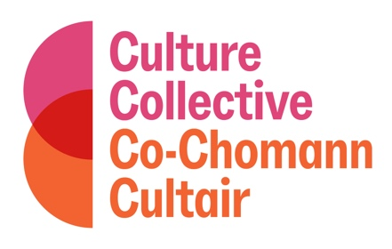
Independent Arts Projects gratefully acknowledges support from Scottish Government and Creative Scotland through the Culture Collective programme.
* Please note: You do not have to complete the Equal Opportunities Monitoring form. However, it is a useful tool for helping us to monitor the effectiveness of our recruitment process. In accordance with the Data Protection Act 1998, the information you have provided will only be used for the purpose of equality monitoring.
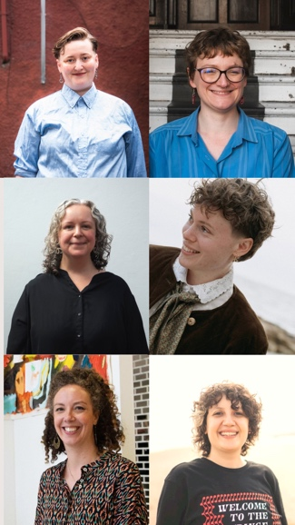
How we work
We are building a small arts organisation that aims to put access and care at the heart of all we do. We want the organisational culture to reflect our values and this central ethos.

The team
Office based staff include: Executive Director Mhari Robinson, General Manager Chloe Lyth, Producer Noémie Lorenzi (full time), and International Producer Sara Shaarawi (part-time & in the office once a week).
Associate Artists Biff Nicolson & Saffy Setohy work part-time with IAP, usually on their own projects and practice and are less in the office. They & all other staff (creative and/or freelance) work remotely in arts & community spaces or on a hybrid basis though some visit the office more than others.
Figure 1 (top left then clockwise): Biff, Chloe, Noemie, Sara, Saffy & Mhari

IAPs Office
We have a first-floor office to the front of the building at Out of the Blue Drill Hall, 36 Dalmeny Street, Edinburgh, EH6 8RG. The office is not step free but accessed by a minimum of 6 steps. The ground floor of the building is step free and has a Café, exhibition space and meeting rooms available. Staff can access a discount in the Café which serves a range of soups and other tasty things. There’s also a shared kitchen with microwave for all tenants. The office is off Leith Walk and accessible via bus, tram or a 25-ish minute walk from Waverley train station.

IAP do not have a studio or defined workspace for creative activity. The Sensory Artists will work in hired spaces to suit the needs of the team and in community spaces, centres, schools, outdoors etc when working with participants.
Working patterns & culture
Independent Arts Projects workflow changes throughout the year with some busier and some quieter periods.

The representation across our current team and board is mainly female and non-binary, with disabled, neurodivergent, LGBTQIA+ and ethnically diverse representation. We are trans inclusive.

We operate an informal office environment and encourage staff to dress comfortably. Staff are welcome to take regular breaks, stim freely and be themselves as much as possible.

We currently have a dog friendly office, but we would make changes if our preferred applicant was allergic.

Sensory Artist (0.6 FTE)
APPLICATION FORM
Application deadline: 12 noon, Monday 21 September 2026
Please read the job pack before completing this form. If you have any questions about how to complete this application form or would like an alternative format or translation, then please email jobs@independentartsprojects.com.
Alternatively, applicants can send a link to a maximum 10-minute-long video that outlines the information below.
Personal details | Your details
Name
Address
Post code
Email address
Telephone number
Link to your CV / details of your professional experience

Interview Guarantee
We will guarantee an interview to any applicant who is either disabled and / or is from the global majority* who also meets the minimum person specification criteria. Do you wish this guarantee to be applied to your application?
Please answer YES or NO.

* By Global Majority, we mean people who have experienced racism including people who are from African and Caribbean diaspora, Latinx, the East Asian Diaspora, the South East Asian Diaspora, from the South Asian Diaspora, West Asian Diaspora (including Middle East), Indigenous people, bi-racial / mixed heritage or who also self-identify as a Person of Colour or Black, or person from the Global Majority. We may use BIPOC+ to refer to people from these identities.

Questions
Please complete the following:
- Tell us a little about your creative practice and why you are interested in this role. (up to 300 words)
- Tell us how your skills, experience, and knowledge match the points mentioned in the person specification in the job pack. (up to 500 words)
- Tell us how you would consider people who face barriers to accessing mainstream arts (e.g. disabled, deaf or neurodivergent people)
(200 words)

Provide details of 2 referees
We will contact your referees after we make an offer subject to references.
 | Referee 1 | Referee 2
Name
Email address
Telephone number
Relationship to you

Please submit this completed application form to jobs@independentartsprojects.com along with your CV by 12 noon, Monday 21 September 2026.

