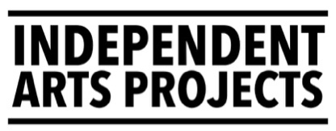
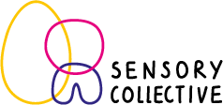
Sensory Artist (0.6 FTE)
APPLICATION FORM
Application deadline: 12 noon, Monday 21 September 2026
Please read the job pack before completing this form. If you have any questions about how to complete this application form or would like an alternative format or translation, then please email jobs@independentartsprojects.com.
Alternatively, applicants can send a link to a maximum 10-minute-long video that outlines the information below.
Personal details | Your details
Name
Address
Post code
Email address
Telephone number
Link to your CV / details of your professional experience

Interview Guarantee
We will guarantee an interview to any applicant who is either disabled and / or is from the global majority* who also meets the minimum person specification criteria. Do you wish this guarantee to be applied to your application?
Please answer YES or NO.

* By Global Majority, we mean people who have experienced racism including people who are from African and Caribbean diaspora, Latinx, the East Asian Diaspora, the South East Asian Diaspora, from the South Asian Diaspora, West Asian Diaspora (including Middle East), Indigenous people, bi-racial / mixed heritage or who also self-identify as a Person of Colour or Black, or person from the Global Majority. We may use BIPOC+ to refer to people from these identities.

Questions
Please complete the following:
- Tell us a little about your creative practice and why you are interested in this role. (up to 300 words)
- Tell us how your skills, experience, and knowledge match the points mentioned in the person specification in the job pack. (up to 500 words)
- Tell us how you would consider people who face barriers to accessing mainstream arts (e.g. disabled, deaf or neurodivergent people)
(200 words)

Provide details of 2 referees
We will contact your referees after we make an offer subject to references.
 | Referee 1 | Referee 2
Name
Email address
Telephone number
Relationship to you

Please submit this completed application form to jobs@independentartsprojects.com along with your CV by 12 noon, Monday 21 September 2026.

